**What is AI? :**

Artificial Intelligence (AI) is a field of computer science focused on creating systems capable of performing tasks that typically require human intelligence. These tasks include reasoning, learning, problem-solving, perception, language understanding, and more. AI encompasses a wide range of technologies, including machine learning, natural language processing, computer vision, and robotics.

**History:**

The history of AI dates back to ancient times when philosophers and mathematicians began to explore the nature of human thought. However, the formal study of AI as a field began in the 20th century.

McCarthy, a computer scientist, coined the term "Artificial Intelligence" in 1956 and organized the Dartmouth Conference, which is considered the birth of AI as a research field. He also developed the Lisp programming language, which became widely used in AI research.

AI research faced challenges in the 1970s due to high expectations and limited computational power. Funding and interest waned, leading to what is known as the "AI winter." Many early AI systems were not as successful as hoped, which led to skepticism about the field's potential.

Geoffrey Hinton, Yann LeCun, and Yoshua Bengio, these researchers are known as the "Godfathers of AI" for their pioneering work in deep learning, a subset of machine learning that has led to significant advances in AI capabilities, including image and speech recognition. Hinton's work on backpropagation and neural networks has been particularly influential.

A leading AI researcher and educator, Andrew Ng co-founded Google Brain and has been a driving force behind the adoption of deep learning in industry. He has stated, "AI is the new electricity," emphasizing the transformative potential of AI across various sectors.

**How AI has changed our lives? :**

AI has already had a profound impact on our daily lives, influencing how we work, communicate, and interact with technology.

**1. Personal Assistants**

AI-powered personal assistants like Siri, Alexa, and Google Assistant have revolutionized how we interact with our devices, allowing for voice-activated commands, reminders, and more.

**2. Healthcare**

AI is transforming healthcare through predictive analytics, personalized medicine, and robotic surgery. AI systems can analyze vast amounts of medical data to assist doctors in diagnosing and treating diseases. For example, IBM's Watson was used to help doctors identify the best treatment options for cancer patients.

**3. Autonomous Vehicles**

Companies like Tesla, Waymo, and Uber are developing self-driving cars that rely on AI to navigate roads, avoid obstacles, and make real-time decisions. These vehicles have the potential to reduce accidents and change the way we think about transportation.

**4. Social Media and Content Recommendation**

AI algorithms curate content on platforms like Facebook, Twitter, YouTube, and Netflix, personalizing the user experience by recommending posts, videos, and products based on individual preferences.

**5. Language Translation**

AI-driven language translation services, such as Google Translate, have made communication across languages more accessible, facilitating global interaction and business.

**6. Job Automation**

AI is automating routine tasks in industries like manufacturing, logistics, and customer service. While this increases efficiency, it also raises concerns about job displacement and the future of work.

However, AI's journey from a theoretical concept to a transformative force in society has been marked by significant milestones and contributions from many brilliant minds. As AI continues to advance, it promises to bring about even more profound changes in how we live, work, and interact with the world. However, these advancements come with challenges that will require careful consideration and responsible stewardship to ensure that AI benefits all of humanity.

**AI in Youube:**



YouTube, one of the largest video-sharing platforms in the world, relies heavily on Artificial Intelligence (AI) to enhance user experience, manage content, and offer personalized services. AI plays a critical role in various aspects of YouTube's operations, from recommending videos to managing content moderation.

**How AI Works on YouTube**

**1. Content Recommendation:**

YouTube uses AI-driven algorithms to recommend videos to users based on their viewing history, preferences, and engagement patterns. This system is powered by machine learning, which allows the platform to continuously improve and personalize recommendations.

The recommendation engine is designed to keep users engaged by suggesting videos that are most likely to interest them. It considers factors such as:

**Watch History:** What videos the user has watched in the past.

**User Engagement:** Likes, shares, comments, and subscriptions.

**Content Similarity:** Videos that are similar to ones the user has interacted with.

**Contextual Information:** The time of day, device type, and even the location can influence recommendations.

**2. Content Moderation:**

YouTube uses AI to automatically detect and remove content that violates its policies, such as hate speech, violent content, and misinformation. This is done through machine learning models that are trained on vast datasets of labeled content.

These AI systems can detect problematic content much faster than human moderators. However, AI isn't perfect, and YouTube also relies on human moderators to review flagged content and make final decisions in more nuanced cases.

**3. Automatic Captioning and Translation:**

YouTube leverages AI for generating automatic captions for videos, which makes content more accessible to a broader audience, including those who are deaf or hard of hearing. The system uses speech recognition technology to transcribe spoken words into text.

AI also plays a role in translating captions into multiple languages, allowing videos to reach a global audience. The translation quality has improved over time thanks to advances in natural language processing (NLP).

**4. Thumbnail Generation:**

AI helps YouTube creators by automatically generating video thumbnails. The system selects the most visually appealing frames from the video that are likely to attract clicks. This feature is particularly useful for creators who may not have the resources or time to design custom thumbnails.

**5. Content Creation Tools:**

AI powers tools like YouTube's "Smart Reply," which suggests quick responses for creators to use in the comment section. This feature uses NLP to understand the context of comments and offers appropriate replies.

AI also assists in content editing, such as improving video quality, color correction, and even generating video previews.

**What AI Offers on YouTube**

**1. Personalized Experience:**

AI-driven recommendations make YouTube highly personalized. Users are more likely to stay engaged because the platform serves them content tailored to their tastes and interests. This has been a key factor in YouTube’s ability to maintain a massive and active user base.

**2. Enhanced Accessibility:**

Automatic captions and translations have made content more accessible to people with disabilities and non-native speakers, expanding the platform's reach.

**3. Content Discovery:**

AI helps users discover new content that they might not have found otherwise. This not only benefits viewers but also content creators who can reach new audiences.

**4. Content Moderation and Safety:**

AI's role in content moderation helps maintain a safer and more welcoming environment on YouTube by filtering out harmful content. This is crucial for protecting users, especially minors, from inappropriate or dangerous material.

**5. Creator Support:**

YouTube offers various AI-powered tools to help creators optimize their content and engage with their audience more effectively. This includes thumbnail generation, Smart Reply, and analytics that offer insights into viewer behavior.

**6. Global Reach:**

AI's ability to translate content allows creators to reach a global audience, breaking down language barriers and expanding the cultural impact of videos.

**Challenges and Criticisms**

Despite the benefits, YouTube's AI systems have faced criticism:

**Bias and Filter Bubbles:** The recommendation algorithm can create "filter bubbles," where users are only exposed to content that reinforces their existing beliefs, potentially leading to polarization. There have also been concerns about algorithmic bias that might promote certain types of content over others.

**Misinformation:** AI moderation systems sometimes fail to catch misinformation or, conversely, mistakenly flag legitimate content as harmful, leading to issues with censorship and freedom of expression.

**Content Monetization:** YouTube's AI can impact how content is monetized, with some creators finding their videos demonetized due to AI misinterpretation of content as inappropriate or controversial.

**The Future of AI on YouTube**

YouTube is likely to continue enhancing its AI capabilities, focusing on:

**Improving Content Moderation:** By making AI moderation more accurate and fair, especially in handling nuanced content.

**Better Personalization:** Refining the recommendation system to avoid issues like filter bubbles while still delivering personalized content.

**AI-Assisted Content Creation:** Developing more sophisticated tools that assist creators in producing higher-quality content, possibly including AI-generated videos, music, and more.

**Ethical AI Development:** Addressing ethical concerns related to AI bias, transparency, and the impact on society to ensure that AI benefits all users.

YouTube's integration of AI is a critical component of its success and evolution, offering users a more personalized and engaging experience while supporting creators in new and innovative ways. As AI continues to advance, YouTube will likely find even more ways to harness its power for the benefit of both viewers and creators.

**AI in Snapchat:**

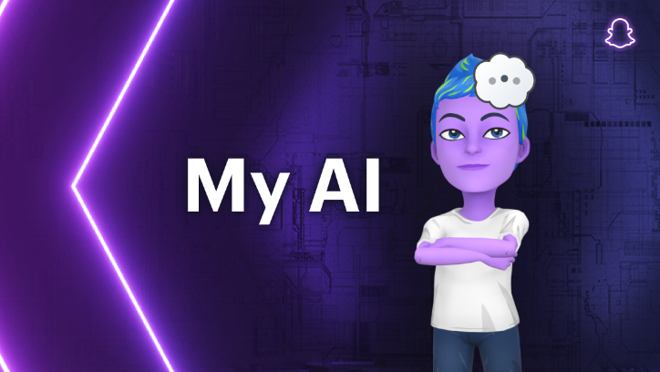

Snapchat, a popular social media platform known for its ephemeral messaging and multimedia sharing features, relies heavily on Artificial Intelligence (AI) to enhance user experiences, drive engagement, and innovate its offerings. Here’s how AI works in Snapchat, what it offers, and the potential future developments.

**How AI Works on Snapchat**

**1. Augmented Reality (AR) Filters and Lenses:**

Snapchat is renowned for its AR filters and lenses, which allow users to superimpose digital content onto the real world through their smartphone cameras. These filters are powered by AI, particularly computer vision and machine learning techniques.

Snapchat’s AI can detect and track facial features in real time, enabling the application of filters that change or augment the user’s appearance, such as adding dog ears, transforming into a cartoon character, or altering facial expressions.

Lens Studio, Snapchat’s tool for creators, uses AI to help users design and deploy custom AR experiences, further enhancing creativity and user interaction on the platform.

**2. Content Recommendation:**

Snapchat uses AI to personalize the Discover section, where users find stories, news, and other content. The platform’s recommendation algorithms analyze user behavior, such as viewing history, interactions, and engagement levels, to suggest content that is most likely to interest the user.

This personalization ensures that users are presented with relevant content, increasing their time spent on the platform and enhancing overall engagement.

**3. Automatic Content Creation:**

Snapchat’s AI-driven tools, such as Cameos and Bitmoji, allow users to create personalized, animated versions of themselves. Cameos use AI to replace faces in short videos with the user’s face, creating a unique and entertaining form of self-expression.

The platform also uses AI to automatically generate captions and recommend relevant hashtags, helping users create more engaging content with minimal effort.

**4. Voice and Gesture Recognition:**

Snapchat has integrated AI-driven voice and gesture recognition features, allowing users to interact with the app in innovative ways. For example, certain lenses can be activated by specific voice commands or gestures, making the user experience more dynamic and intuitive.

**5. Content Moderation:**

AI is also employed in content moderation on Snapchat, helping to detect and remove inappropriate or harmful content. This includes identifying explicit material, hate speech, or bullying, which the platform then filters out to maintain a safe environment for users.

Additionally, AI is used to enforce community guidelines and ensure that content adheres to Snapchat’s standards, though human moderators are still involved in making final decisions on complex cases.

**6. Advertising and Monetization:**

Snapchat’s AI analyzes user data to deliver targeted ads that are more likely to resonate with individual users. By understanding user preferences, behaviors, and demographics, Snapchat can provide advertisers with highly specific targeting options.

AI also helps optimize ad placements and formats, ensuring that ads are shown at the most effective times and in the most engaging ways.

**What AI Offers on Snapchat**

**1. Enhanced User Engagement:**

AI-powered AR filters and lenses are a major attraction on Snapchat, driving high levels of user engagement. These features are fun, interactive, and continuously evolving, keeping users entertained and coming back to the app.

**2. Personalized Content Experience:**

The AI-driven content recommendation system ensures that users are shown content that matches their interests, making their experience on Snapchat more personalized and enjoyable.

**3. Innovative Self-Expression Tools:**

Snapchat’s AI tools like Cameos and Bitmoji offer users new ways to express themselves, making communication on the platform more creative and personalized.

**4. Improved Safety and Moderation:**

AI-driven content moderation helps Snapchat maintain a safe environment, protecting users from harmful or inappropriate content and ensuring that the platform remains a positive space for interaction.

**5. Effective Advertising:**

By leveraging AI for ad targeting, Snapchat offers advertisers a powerful tool for reaching the right audience, leading to more effective ad campaigns and better monetization opportunities for the platform.

**Challenges and Criticisms**

Despite the advantages, Snapchat’s use of AI has not been without challenges:

**Privacy Concerns:** The extensive use of AI to analyze user behavior raises concerns about privacy and data security. Users are increasingly aware of how their data is being used, and Snapchat must navigate these concerns carefully to maintain trust.

**Content Moderation Accuracy:** While AI helps in filtering content, it is not infallible. Mistakes in content moderation can lead to the wrongful removal of content or failure to catch harmful material, potentially affecting user experience.

**Algorithmic Bias:** Like all AI-driven platforms, Snapchat’s recommendation and moderation systems can exhibit biases, leading to unequal treatment of content or users based on race, gender, or other factors.

**AI in DuoLingo:**

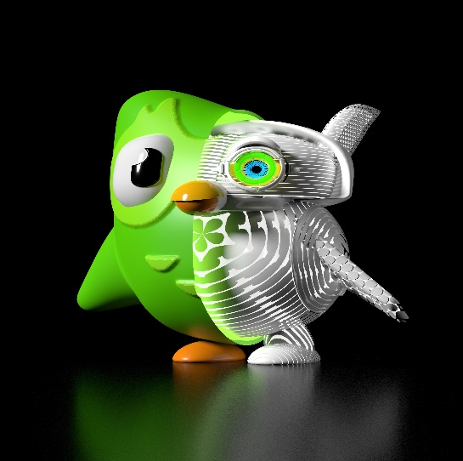

Duolingo, a popular language-learning platform, has effectively harnessed the power of Artificial Intelligence (AI) to personalize learning experiences, enhance user engagement, and improve language acquisition. AI plays a central role in everything from content creation and adaptive learning to user assessment and motivation on the platform. Here's how AI works on Duolingo, what it offers, and what the future might hold.

**How AI Works on Duolingo**

**1. Personalized Learning Pathways:**

Duolingo uses AI to create personalized learning experiences tailored to each user’s strengths, weaknesses, and learning pace. The platform's AI algorithms analyze user data to determine which exercises and lessons should be presented next, ensuring that learners are neither bored with repetitive tasks nor overwhelmed with too challenging content.

The AI adapts in real-time, continuously adjusting the difficulty and focus of exercises based on how the learner is performing. This dynamic adaptation is known as adaptive learning, which helps maintain an optimal level of challenge to keep users engaged and progressing.

**2. Natural Language Processing (NLP):**

NLP is a crucial component of Duolingo's AI. It enables the platform to understand, process, and generate human language in a way that mimics natural conversation. NLP powers Duolingo’s translation exercises, sentence construction tasks, and even the chatbot interactions that help users practice conversational skills.

AI-driven NLP also helps in providing instant feedback on users' responses, identifying common errors, and offering corrections that are contextually relevant.

**3. Spaced Repetition System (SRS):**

Duolingo employs a Spaced Repetition System (SRS) powered by AI to help users retain information more effectively. SRS is a learning technique where information is reviewed at increasing intervals based on how well the learner remembers it.

AI determines the optimal timing for reviewing specific words or grammar rules to reinforce memory and prevent forgetting. The system dynamically adjusts these intervals based on user performance, ensuring that the most challenging material is reviewed more frequently.

**4. Gamification and Engagement:**

AI is central to Duolingo’s gamification strategies, which include features like streaks, leaderboards, and reward systems. By analyzing user engagement patterns, AI helps Duolingo optimize these features to keep users motivated and coming back to the app regularly.

AI also powers Duolingo’s Daily Goal Setting feature, where it suggests achievable goals based on past performance and learning behavior, helping users stay on track with their language-learning journey.

**5. Voice Recognition:**

Duolingo uses AI-driven voice recognition technology to evaluate users' pronunciation during speaking exercises. This technology assesses the accuracy of spoken responses, offering instant feedback to help users improve their pronunciation skills.

The AI models are trained on large datasets of spoken language to recognize various accents and dialects, making the platform more accessible to a diverse global audience.

**6. Content Creation and Curation:**

Duolingo leverages AI to generate and curate content, including sentences, exercises, and quizzes. AI helps in creating new language-learning content that is both educational and engaging. The platform also uses AI to analyze the effectiveness of different types of content and optimize them based on user feedback and learning outcomes.

**What AI Offers on Duolingo**

**1. Personalized Learning Experience:**

AI-driven adaptive learning ensures that each user’s experience on Duolingo is tailored to their individual needs, providing just the right level of challenge to maximize learning efficiency and engagement.

**2. Effective Language Retention:**

Through the use of SRS and personalized review schedules, AI helps users retain what they’ve learned over the long term, making language acquisition more effective and enduring.

**3. Instant and Accurate Feedback:**

AI provides immediate feedback on exercises, helping users understand their mistakes and learn from them in real-time. This is particularly beneficial for improving language skills like pronunciation, grammar, and vocabulary.

**4. Increased Motivation and Engagement:**

Duolingo’s AI-powered gamification elements, such as streaks, rewards, and personalized goals, keep users motivated and engaged, transforming language learning into a fun and addictive activity.

**5. Accessibility and Inclusivity:**

AI ensures that Duolingo’s learning experience is accessible to a broad audience, accommodating different learning styles, paces, and even recognizing diverse accents and dialects during speaking exercises.

**6. **Scalability of Learning Content:\*\***

- AI enables Duolingo to scale its content creation, ensuring that users always have access to fresh, relevant, and high-quality learning materials. The platform can introduce new languages and courses more efficiently thanks to AI-driven content generation.

**The Future of AI on Duolingo**

The future of AI on Duolingo looks promising, with several potential advancements:

**1. Improved Conversational AI:**

Duolingo is likely to continue enhancing its chatbot and conversational AI features, making them more sophisticated and capable of simulating real-life conversations with greater accuracy and fluency.

**2. Enhanced Personalization:**

The platform may further refine its adaptive learning algorithms to offer even more personalized and contextually aware learning experiences, possibly integrating AI that can assess and respond to a user’s emotional state or learning environment.

**3. Advanced Pronunciation Feedback:**

Future developments might include more advanced voice recognition technology that can provide even more detailed feedback on pronunciation, intonation, and speaking fluency.

**4. Expanded Language Offerings:**

AI could play a key role in rapidly developing and rolling out courses for less commonly taught languages, making Duolingo a more inclusive platform for global users.

**5. AI in Cultural Learning:**

Duolingo might integrate AI-driven cultural learning modules, helping users not only learn a language but also understand the cultural context in which it is used, thereby offering a more holistic language-learning experience.